* Learn essential safety skills *

*Earn your HOSTA Safety Certification*

Capital District 4-H Tractor Safety

Monday, April 22-Wednesday- April 24

# Open to all youth ages 14 and above

Cornell Cooperative Extension of Fulton & Montgomery counties   
4-H would like to welcome all area youth (4-H and non 4-H) who are 14 years old and older, to participate in the 2019 Capital District 4-H/HOSTA Tractor Safety Program at the Washington County Fairgrounds. This program is a great opportunity for youth who currently work on farms or around machinery, those who will be seeking employment on a farm, or anyone who would just like to learn more about farm and machinery safety.

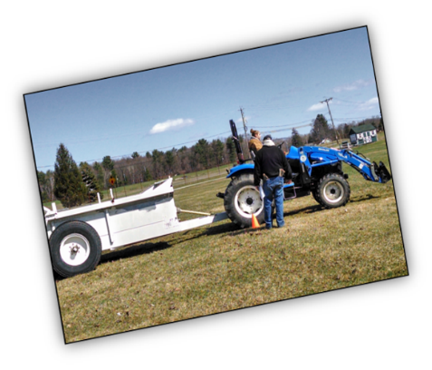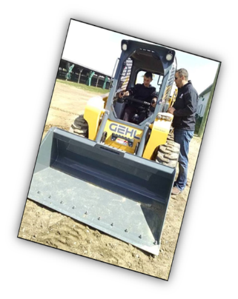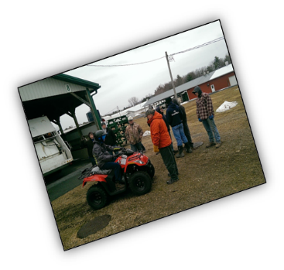

**Cost is $30/4-H members and   
$35/non 4-H members**

***Register by March 15 online at*   
https://reg.cce.cornell.edu/2019Tractor_210**  
  
***or submit a check (made payable to CCEFM) or cash to the 4-H Office.***

## ***Learn essential safety skills * Earn your HOSTA Safety Certification***